|  |  |  |
| --- | --- | --- |
| SCHOOL OF INFORMATION AND TECHNOLOGY | | |
| NAME: | DATE PERFORMED: |  |
| Section: | DATE SUBMITTED: |

# SYSADM1 – Managing Services in Linux

# Requirement:

* A virtual machine running Linux

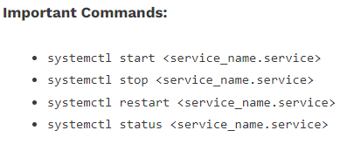

Complete this lab as follows:

Use the service –status-all command to list all active and inactive services.

List down active and inactive services in the table below. Provide five (5) services for each column.

|  |  |
| --- | --- |
| **Active** | **Inactive** |
|  |  |
|  |  |
|  |  |
|  |  |
|  |  |

SS:

Start the Bluetooth service using the systemctl command.

Ex. sudo systemctl start httpd



Check the status of the Bluetooth service. What is its status?

SS:

Check the status of the cups services. Since when was it running?

SS:

Stop cups services.

Verify if the service was stopped.

Restart the cups services

Verify if the service was restarted.